College Management System

**OOPM Mini Project**

Anmol | Anooj | Nimali | Janhavi

**CERTIFICATE:**

This is to certify that, **Mr. Anmol Majithia**, of **SE Comps, A. P. Shah Institute Of Technology** has successfully complete his **Mini Project** in the subject of **OOPM**.

ACKNOWLEDGEMENT

There are many people who have helped us directly or indirectly in the successful completion of our project. We would like to take this opportunity to thank one and all.

It is our sincere obligation to thank Prof. Sachin Malve Sir, Head of COMPUTER DEPARTMENT, APSIT, who gave us the great opportunity to make this project.

We are very thankful to our project guide Prof. Ram Kumar Sir who has been an inspiring guide and a committee. The encouragement and support by him, especially in carrying out this project motivated us to complete this project.

We would like to express a deep sense of gratitude to our staff members of Dept. of COMPUTER for their co-operation, which has given in the congruency to build up this project. Priya Merlin Ma’am, Brinal Colaco Ma’am and Sachin Takmare Sir, thank you for helping us out with this project.

We would like to thank all our friends for their help and constructive criticism during our project period. Finally, we are very much indebted to our parents for their moral support and encouragement to achieve this goal. We have no words to express our gratitude. Thank You.

**Table Of Contents:**

|  |  |
| --- | --- |
| Certificate | 1 |
| Acknowledgment | 2 |
| Introduction | 4 |
| Software Requirements | 5 |
| Hardware Specifications | 5 |
| Abstract | 6 |
| Feasibility Analysis | 8 |
| Modular Description | 9 |
| System Implementation | 10 |
| Database Schema | 22 |
| Conclusion | 23 |

**INTRODUCTION OF THE COLLEGE MANAGEMENT SYSTEM**

The main objective of COLLEGE MANAGEMENT SYSTEM is to automate all functionalities of a college or university. Using this system, you can manage all college management work like admission, fees submission, time table management and result declaration. Using this college management system, you can view or update data and information about students and staff easily. This system helps in managing the activity like student admission, student registration, fees submission. Admin can also retrieve information of employee, staff and student.

The COLLEGE MANAGEMENT SYSTEM can be used to store student information like attendance, fees, and student result etc. Admin can create report regarding any student any time using this system. Using this system, you can register new student and their course details. You can submit student fees and can check fees details anytime. You can create exam result and submit in this system. Student can check their result by logging to the system. You can also add new employee in the system and can check details of the employee easily. Student can also check course detail online from this system.

COLLEGE MANAGEMENT SYSTEM can store and manage all data of the various departments of a college like Administration, Attendance, Staff details etc. using this system user can retrieve any information related to student, teacher and fees. Using this system teacher can check student attendance anytime. This system also help teacher to announce the result. College administration can also manage college work easily. They can also create time table of classes from this system.

SOFTWARE REQUIREMENTS

❑ Front End- Java(jdk1.8) and above

❑ OS-All (Java is Platform independent)

❑ Back End- Oracle, MySQL

HARDWARE SPECIFICATIONS

❑ Processor 1.0GHZ

❑ Hard Disk 40GB

❑ RAM 512MB

ABSTRACT

An organized and systematic oﬃce solution is essential for all universities and organizations. There are many departments of administration for the maintenance of college information and student databases in any institution. All these departments provide various records regarding students. Most of these track records need to maintain information about the students. This information could be the general details like student name, address, performance, attendance etc or speciﬁc information related to departments like collection of data. All the modules in college administration are interdependent. They are maintained manually. So, they need to be automated and centralized as, Information from one module will be needed by other modules. For example, when a student needs his course completion certiﬁcate it needs to check many details about the student like his name, reg number, year of study, exams he attended and many other details. So it needs to contact all the modules that are oﬃce, department and examination and result of students. With that in mind, we overhauled the existing College Management System and made necessary improvement to streamline the processes. Administrators or the Admin using the system will ﬁnd that the process of recording and retrieving student’s information and is now a breeze. Teaching staff managing their classes, including marking of attendance. In general, this project aims to enhance eﬃciency and at the same time maintain information accurateness. Later in this report, features and improvement that allow achievement to this goal will be demonstrated and highlighted. Our work is useful for easy user interface. We are planning to utilize the powerful database management, data retrieval and data manipulation. We will provide more ease for managing the data than manually maintaining in the documents. Our work is useful for saving valuable time and reduces the huge paper work.

This system is being developed for an engineering college to maintain and facilitate easy access to information. For this the users need to be registered with the system after which they can access or modify data as per the permissions given to them.

College Management System is an internet-based application that aims at providing information to all the levels of management with in an organization. This system can be used as a knowledge/information management system for the college. For a given student/staff (technical/Non-technical) can access the system to either upload or download some information from the database.

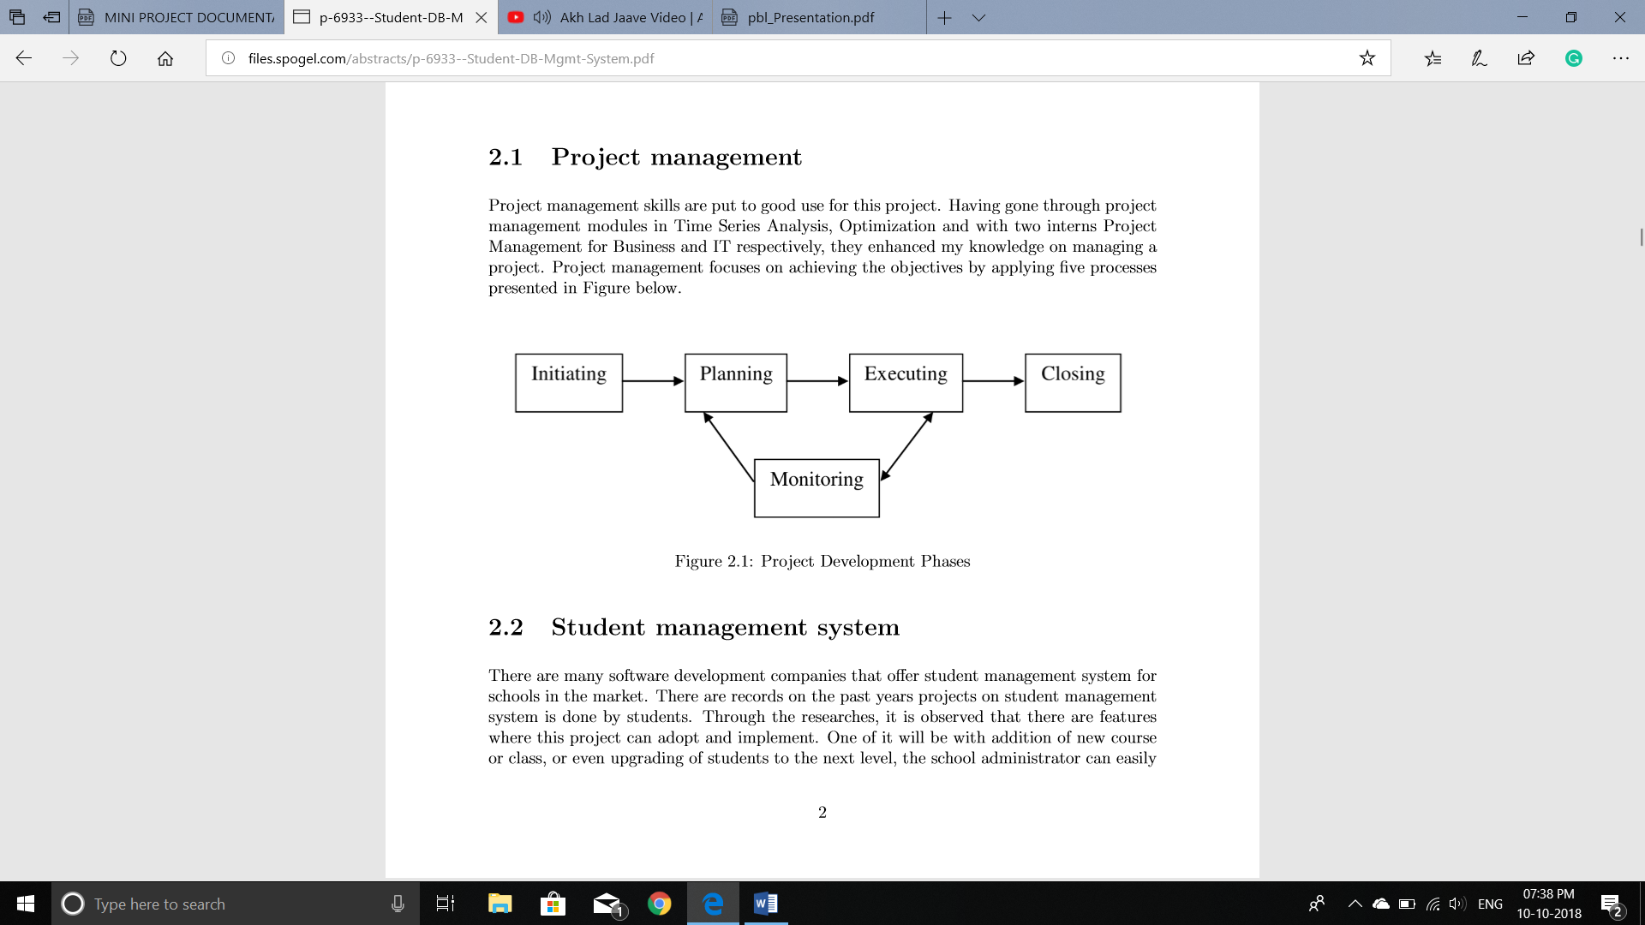

FEASIBILITY ANALYSIS

o TECHNICAL FEASIBILITY:

The proposed system is technically feasible as it can be developed easily with the help of available technology.

o OPERATIONAL FEASIBILITY:

Automation makes our life easy. The proposed system is highly user friendly and much easily able interact with the system.

**EXISTING SYSTEM:**

In the existing system, the manual process, receiving data from students and staff details are done through manual records. These records are entered in manual process.in this process will take long time; separate workers need to maintaining the databases. All the college details are stored via separate databases. It will take long time due to this process time waste, money waste etc... In this process very difficult to maintain the fees and accounting reports of college in proper way. Teacher does not maintain the file, documentation, reports (class Wise, section wise) etc…

**NEED FOR PROPOSED SYSTEM**

The main objective of the existing system is to provide a user-friendly interface. The system, which is proposed, now computerizes all the details that are maintained manually. Once the details are fed into the computer there is no need for various persons to deal with separate sections. Only a single person is enough to maintain all the reports. The security can also be given as per the requirement of the user

* Large volumes of data can be stored with case.
* Maintenance of file is flexible.
* Records stored are updated now and then.
* Stored data and procedures can be easily edited.
* Reports can be generated with case.
* Accurate calculations are made.
* Less manpower required.

Modular Description:

System Implementation:

Module 1 (Main module):

Opening Page: It consists of: o Contact us. o About us. o Login.

- “Contact us”: simply contains the ways to reach and contact the College.

- “About us”: to know more about the college.

The next Module is chosen depending on the UID and Password entered.

- “Login” Further consist of 3 modules:

1. Admin

2. Teacher

3. Student

All modules have their own Specifications. Each are explained in further slides.

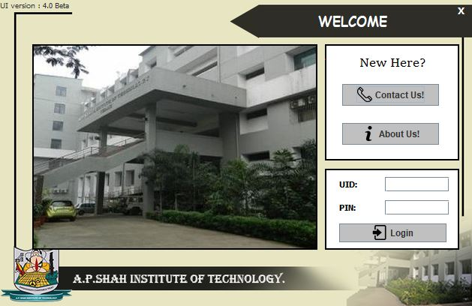

**Contact Us:**

* Address to reach the location
* Email and phone no. to contact the College in case any need

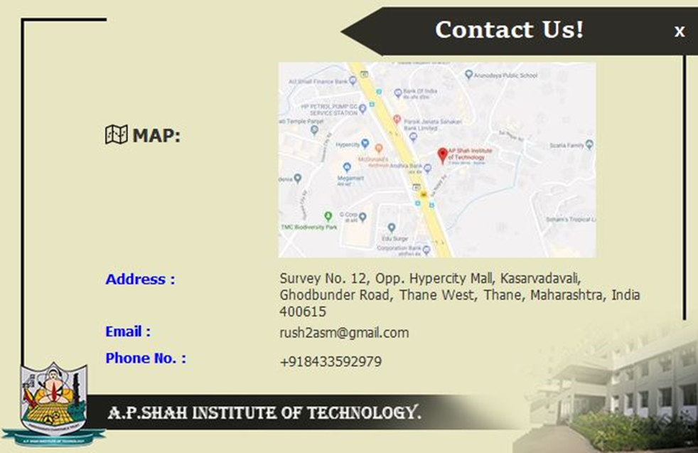

**About Us:**

* To know about the college, their specification and to learn more about the fields and course provided by the college.

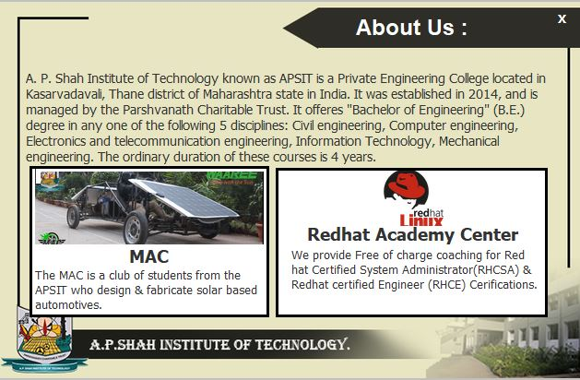

**Admin’s Portal** :

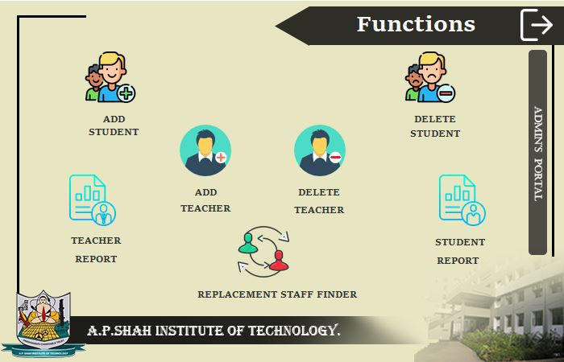

After you login with the admins login details, you get to see the following modules in it:

* Add Student: to enrol a new admission. It would be directly added to the database.
* Add Teacher: to enrol new teachers. It would be directly added to the database.
* Delete Student: to delete the details of the student who has left the college, all the details would be deleted from each table of the database too.
* Delete Teacher: to delete the details of the teacher, all the details would be deleted from each table of the database too.
* Teacher’s Report: it provides you to see all the Teachers together. The Export button provided converts all the visible teachers details in an “.xls” file format
* Student’s Report: it provides you to see all the students together. The Export button provided converts all the visible student details in an “.xls” file format
* Replacement Staff Finder: Helps the admin to find teachers who are free in the given time slot to call upon as substitute teachers

Only admin is allowed to edit in these fields.

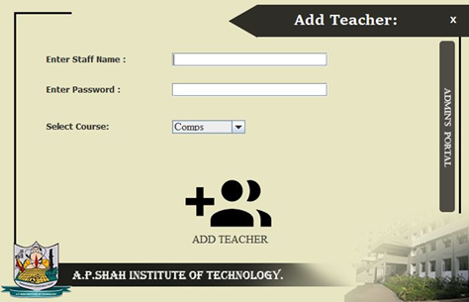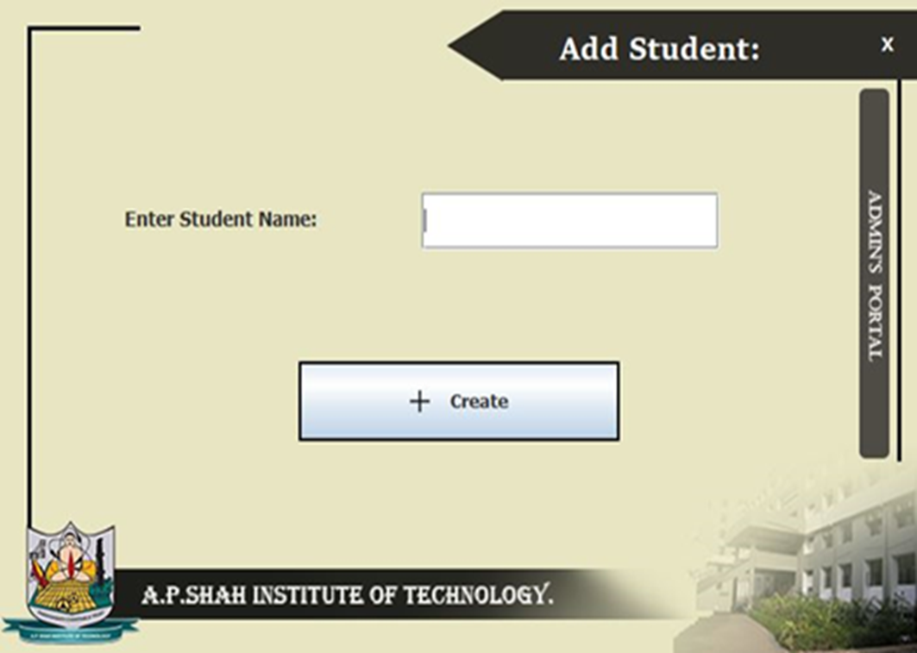

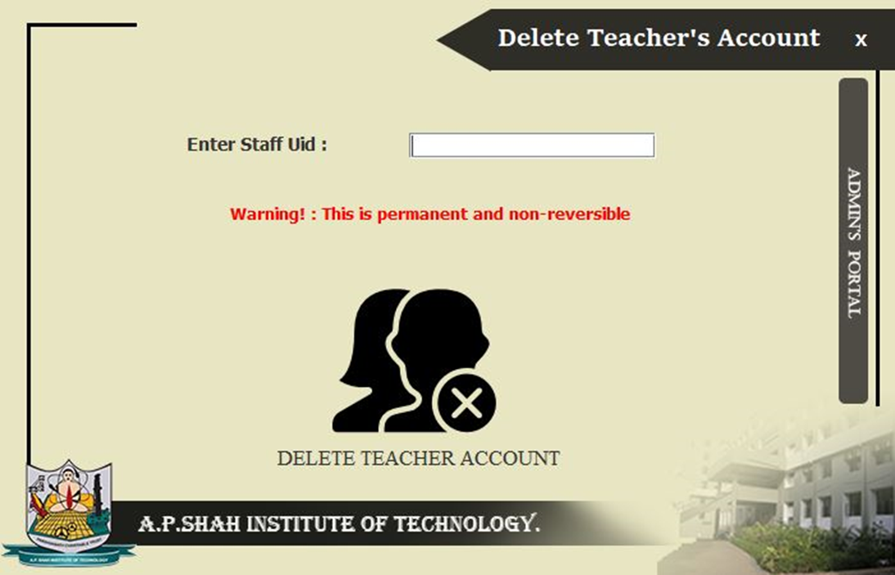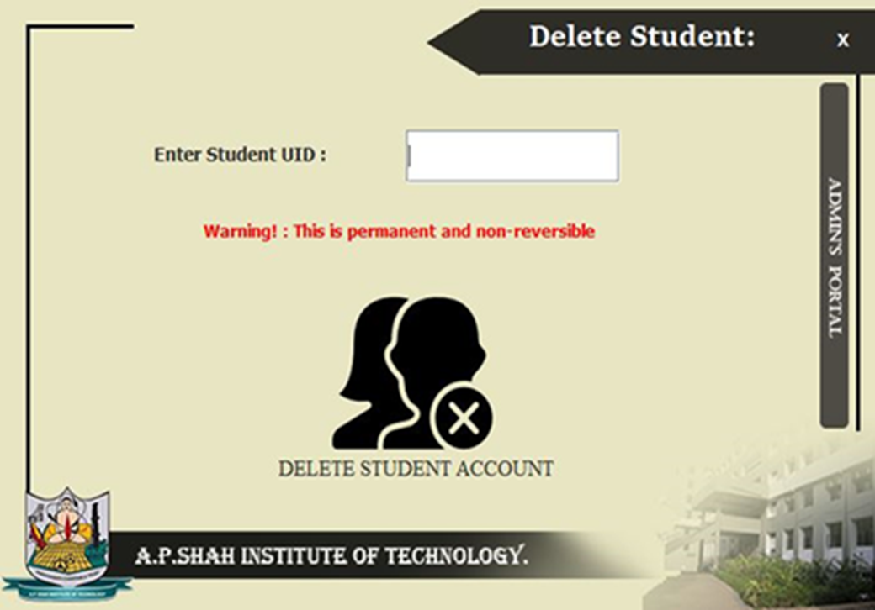

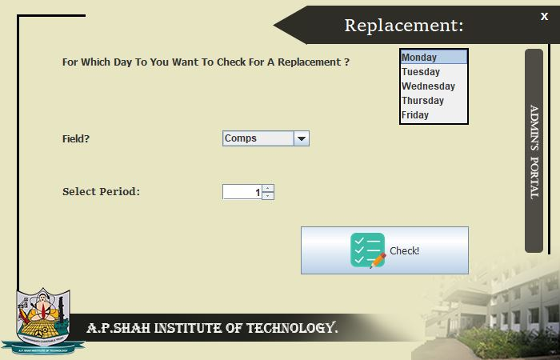

**Teacher’s Portal**

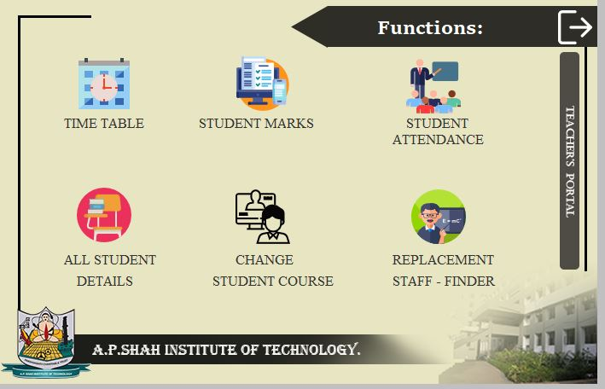

After you login with a teachers login details, you get to see the following modules in it:

* Timetable: Opens up an option to choose and edit a teacher’s personal timetable or the whole fields timetable. Changes made in the fields timetable can be seen by all students of that field as well.
* Student Marks: Allows the teacher to select the student and enter their marks in all 6 subjects
* Student Attendance: Allows the teacher to select date and enter the UIDs of present/absent students
* All Student Details: Shows the teacher the details of all the students of her field
* Change Student Course: Allows the teacher to change the course of a student from one field to the other, while doing this it also changes the status of the seat numbers
* Replacement Staff Finder: Helps teachers to find free teachers in a given time slot of their field only.

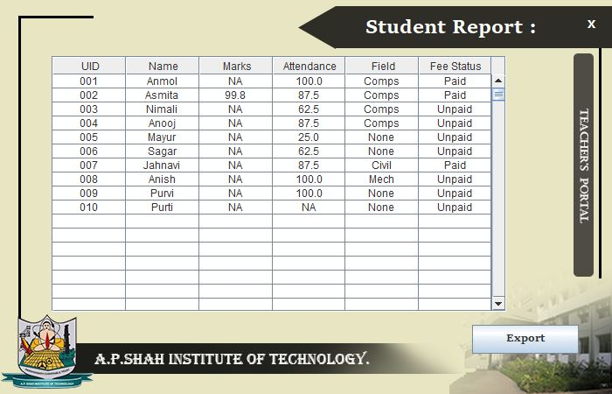

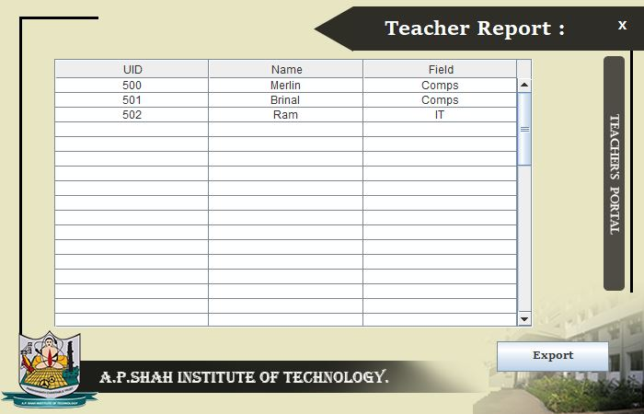

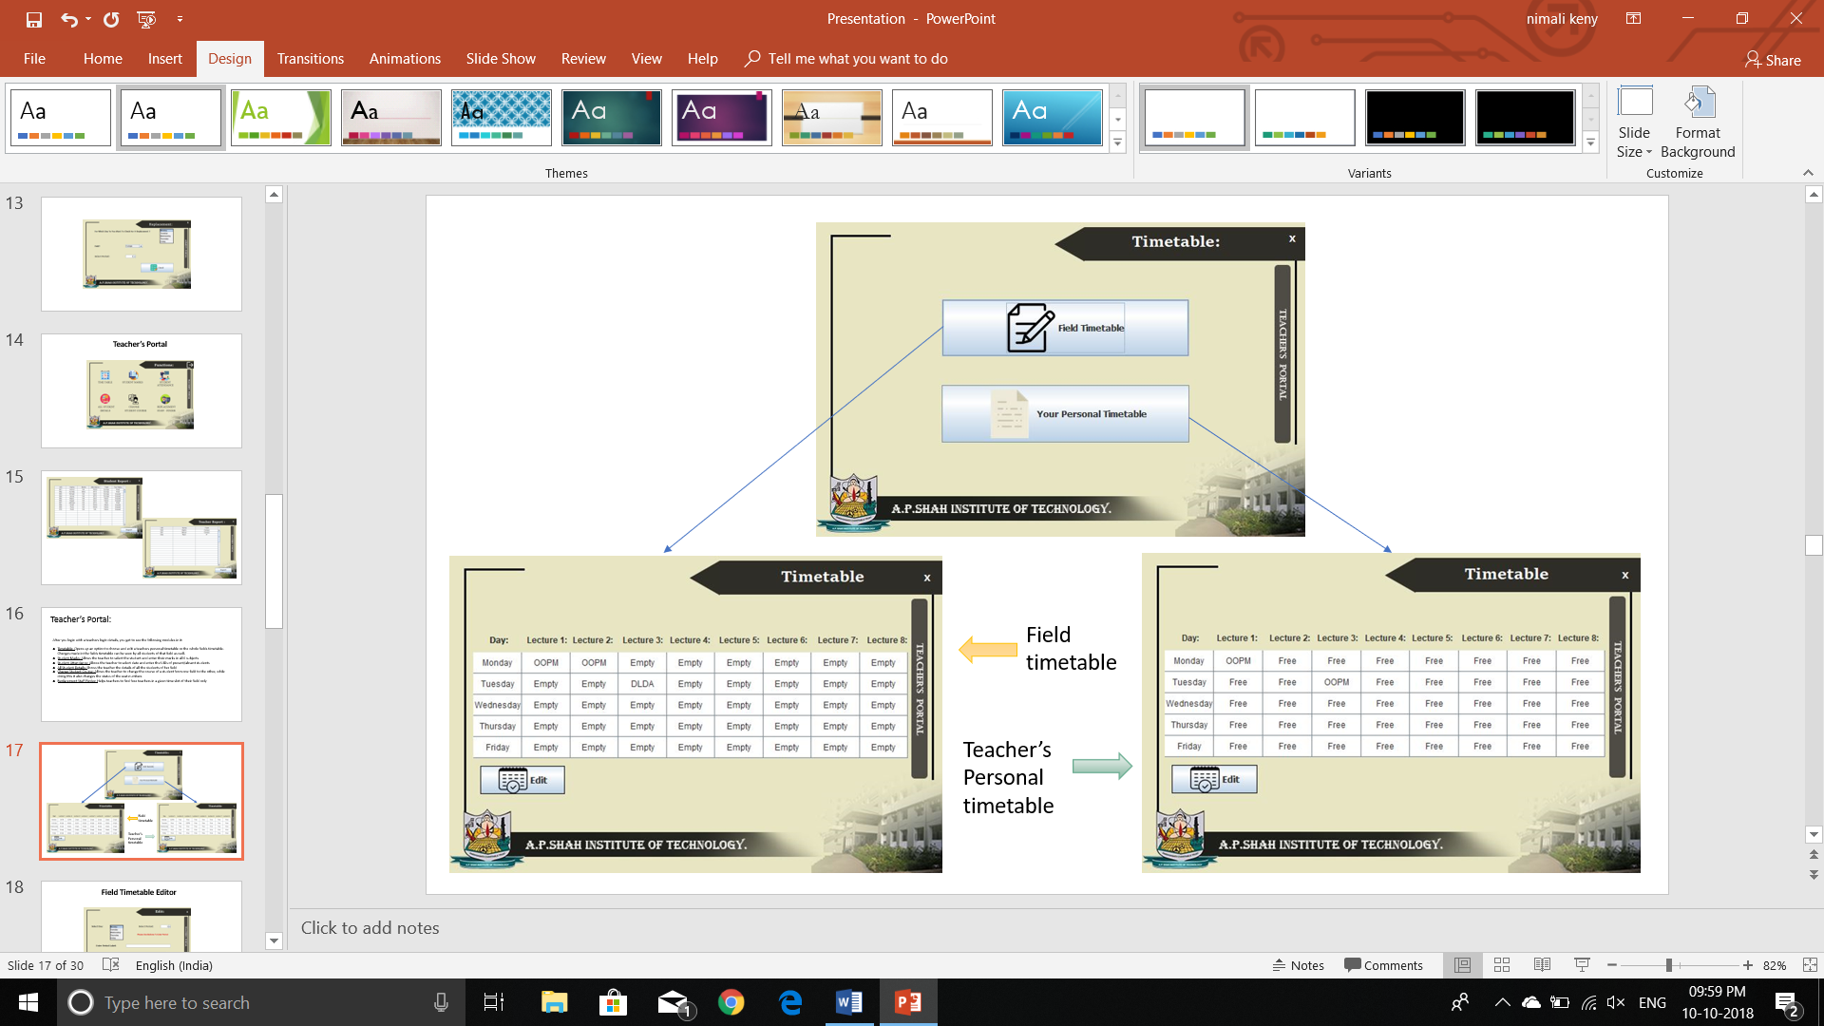

**Field Timetable Editor**

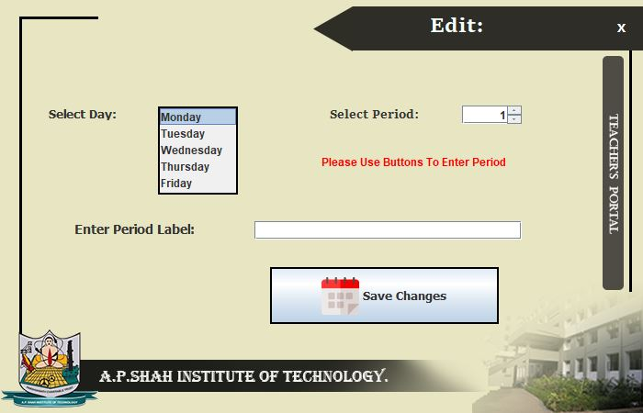

**Personal Timetable Editor**

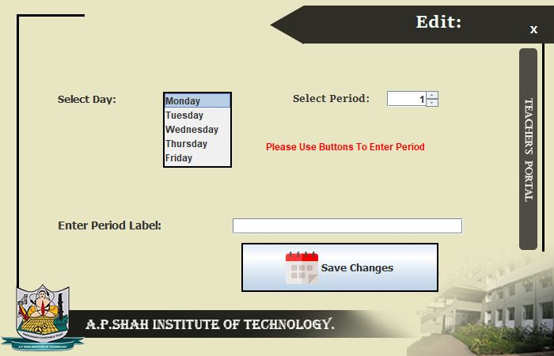

Attendance: Marks:

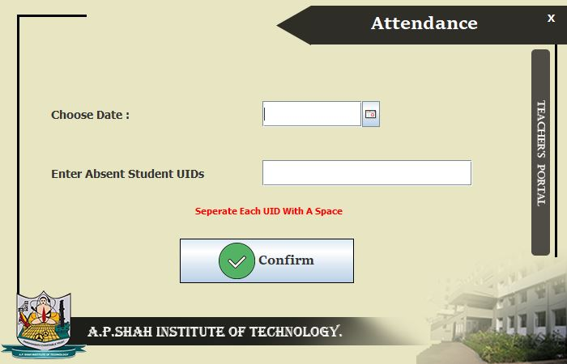 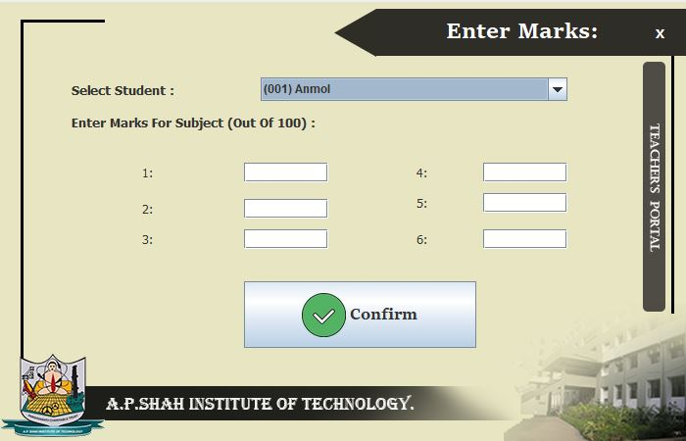

For Changing Course:

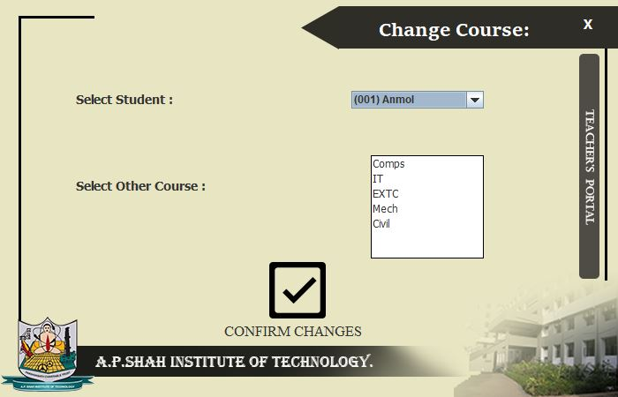

**Student’s Portal:**

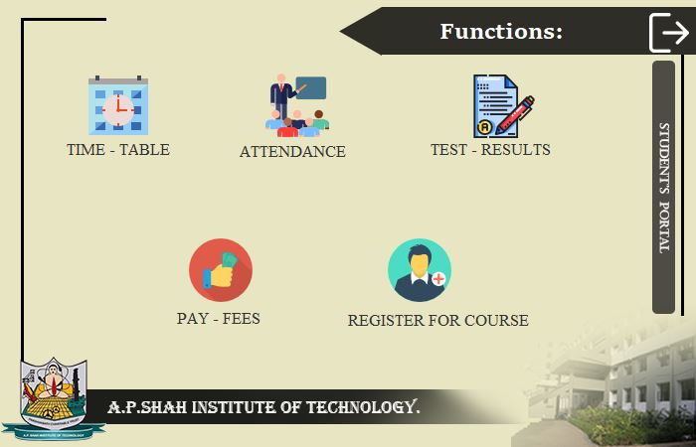

After you login with a student’s login details, you get to see the following modules in it:

* Timetable: Displays the students respective field timetable based on their registered field.
* Attendance: Displays the students percent attendance.
* Test Results: Displays the students percentage scored in exams, as entered by the teacher.
* Pay Fees: Opens up the fee payment portal which displays the students name, field selected and amount to be paid, if fee is not paid it takes him to the payments portal where if he enters all the right bank account details, the transaction is completed and fee is considered paid.
* Register For Course: Allows the student to choose a particular course.

**Register for Course**: P**ay Now Portal:**

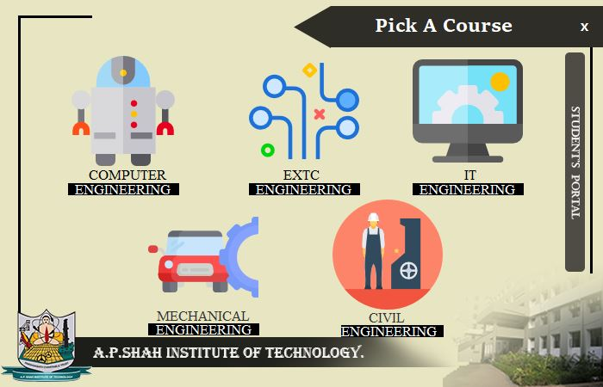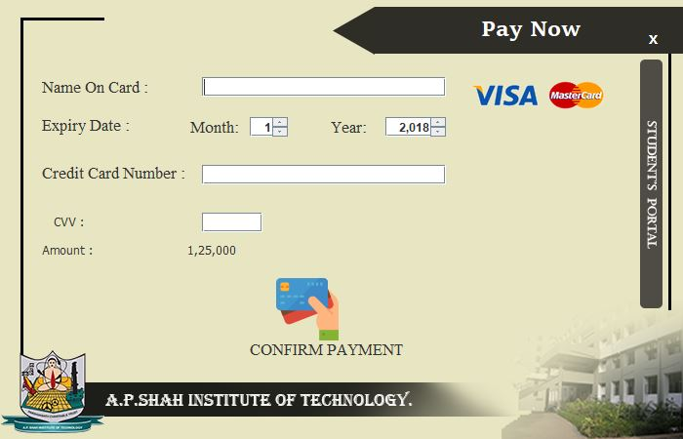

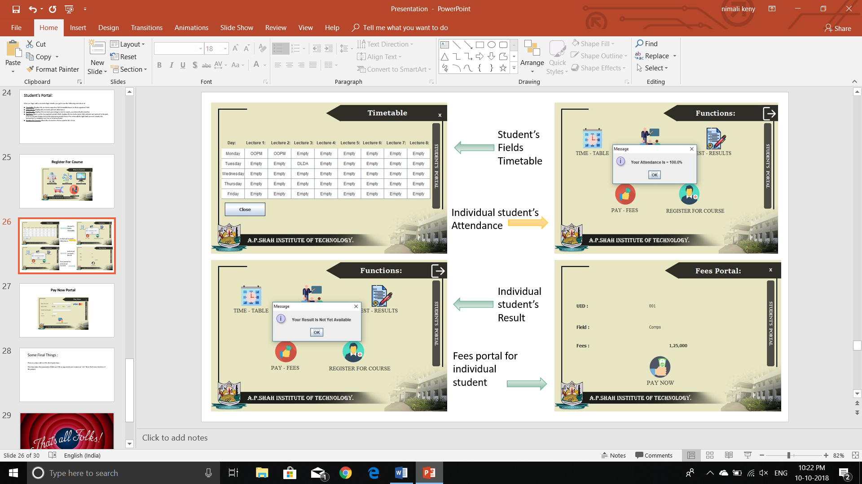

**Some Final Things :**

* There is a class with no GUI, the Export class:

This class takes the parameters JTable and File as arguments and creates an “.xls” file in the home directory of the project

**Database Schema:**

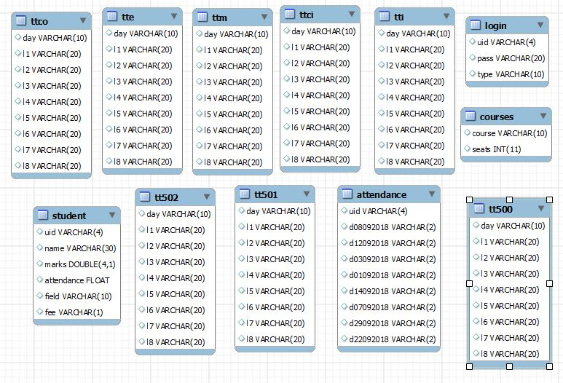

**Conclusion:**

This paper presents a method for increasing information requested by students with the use of automated College Management System. In this, instead of direct Contacting with direct Contacting with the faculty the student can directly checks the Results from the System if the student is registered in College Management System.

College Management System helps educational institute to do regular activities accurately, quickly and reliably.

By using College Management System student and faculty can find out overall attendance percentages, fee details and result analysis.

CMIS increases quality in work for educational institutes.

The software facilitates the administrators to know the present status of a student of the college.

The software gives the information such as student personal data, student fees details, results etc.

Generating the print reports of student personal, fee as well as result details….

Hence, we conclude that the present system (College Management System for Colleges) would definitely help the user by saving time and effort by reducing the processing time and volume of errors.

The efficiency of the work done would be improved and work satisfaction on the part of the employees after computerization would definitely on high.

The customer satisfaction would be definitely higher when compared to the old manual system